Context:

Sustainability

Decision Analysis: Precision Agriculture techniques for Tropical systems

Choose: location, technology with available data/references

Options: smallhoder farmers, tropics, economic factors

Crop or group of crops (monocrop)

Agoforestry?

Laser leveling-> too expensive? Promotes monoculture (not environmentally sound)

Frederic Schönbach, marina, sara, kent, grace

Topic: Precision Agriculture/Smart farming in tropics

Location and crop to decide

Mind Map

### Data available:

* Costs (China, [winterwheat](https://drive.google.com/file/d/1EYYhoa21MNA_LcSqGeyPUR2-94UGl3xp/view?usp=sharing))
* Economic benefits ([China, winter wheat](https://drive.google.com/file/d/1EYYhoa21MNA_LcSqGeyPUR2-94UGl3xp/view?usp=sharing))-> NDVI (Normalized Difference Vegetation Index), GUI (Growth Uniformity Index)-> (future year benefits)
* Benefit/cost ratio ([China, winter wheat](https://drive.google.com/file/d/1EYYhoa21MNA_LcSqGeyPUR2-94UGl3xp/view?usp=sharing))-> exceeded baseline by 10%
* Crop yield (Eastern [Afghanistan](https://drive.google.com/file/d/1hECherYLOOf7ku7yLh2VdQh2_wsRpgY8/view?usp=sharing)) -> yield increased by 21%, 40%, and 38% wheat, corn, and eggplant

->(Rice-wheat [Northwest India](https://drive.google.com/file/d/1921TWo76tej9OxVR6hCPfNHxUwOlmuhU/view?usp=sharing))-> increased yield by 7% in rice; increased by 6.7% in Haryana and 8.8% in Punjab for wheat; translates to USD 138 ha-1 yr-1 additional benefit per farmer. Adopting LLL, even in 50% of the area under rice-wheat system in the Haryana and Punjab states can provide additional production of 699 million kg of rice and 987 million kg of wheat, amounting to USD 385 million/yr.

* Water efficiency (Eastern [Afghanistan](https://drive.google.com/file/d/1hECherYLOOf7ku7yLh2VdQh2_wsRpgY8/view?usp=sharing)) -> water demand reduced by 21%, 27%, and 17% for wheat, corn, and eggplant
* Water productivity Eastern [Afghanistan](https://drive.google.com/file/d/1hECherYLOOf7ku7yLh2VdQh2_wsRpgY8/view?usp=sharing))-> increased by 39%, 53%, and 37% for wheat, corn, and eggplant
* Groundwater use ([Punjab, Pakistan](https://drive.google.com/file/d/1fdPDBgxOeaVL5H1W-WXuGhMAYrUbp5Ij/view?usp=sharing))- reduced groundwater use by about 23%.
* Irrigation time (rice-wheat, [Northwest India](https://drive.google.com/file/d/1921TWo76tej9OxVR6hCPfNHxUwOlmuhU/view?usp=sharing))->reduced irrigation time by 47-69 h/ha per season in rice; 10-12 h/ha per season reduction in wheat. Savings in irrigation

time reduced the number of operation of tube wells for pumping water= savings of 558-762 kWh of electricity ha-1 yr-1 or 300-410 litres of diesel ha-1 yr-1.

* Environmental footprint (rice-wheat, [Northwest India](https://drive.google.com/file/d/1921TWo76tej9OxVR6hCPfNHxUwOlmuhU/view?usp=sharing)): savings of 558-762 kWh of electricity ha-1 yr-1 or 300-410 litres of diesel ha-1 yr-1 translates to reduced environmental footprint.
* Factors affecting adoption in Haryana, India (rice-[wheat systems](https://drive.google.com/file/d/1bwS57KgsQO7BxZwHoBAWTCUtCJ4Yt5Mc/view?usp=sharing))-> *farm size* (larger farms more likely to adopt). Information about technology through farmer-to-farmer communication and through private traders, *participation in agricultural training* and *membership in local agricultural institutions* increased both the likelihood and the intensity of adoption. There is negative association between land holdings and the proportion of laser-leveled land. Conclusion: *closer collaboration* among the various stakeholders, to promote *farmer-to-farmer communication* through i*ncreased participation in local institutions* and increase the rate of adoption
* Scalability (rice-wheat, [Northwest India](https://drive.google.com/file/d/1921TWo76tej9OxVR6hCPfNHxUwOlmuhU/view?usp=sharing)): LLL is a scale neutral technology i.e., not biased towards large farmers
* Key factors affecting speed of adoption ([Punjab, Pakistan](https://drive.google.com/file/d/1fdPDBgxOeaVL5H1W-WXuGhMAYrUbp5Ij/view?usp=sharing)): strong legal land rights, access to information about the technology, and exposure to the technology. Long distance to rental market deaccelerates the speed of adoption (logistics). Conclusion: improving access to extension services, exposure to innovation, and legal land rights can enhance the adoption and diffusion of the technology.

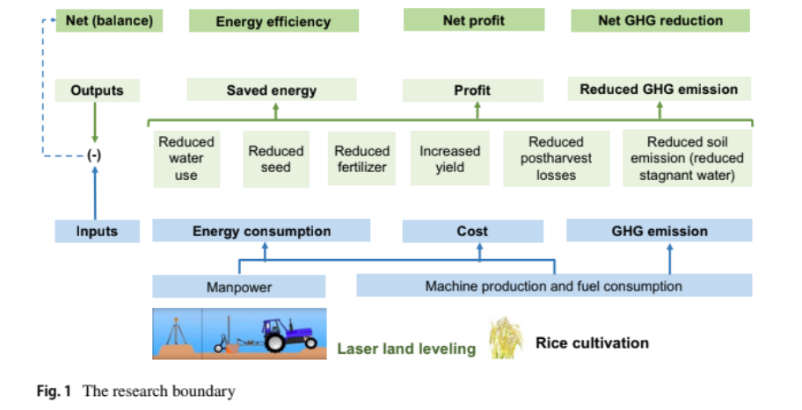

Source: https://drive.google.com/file/d/1Lj4Ij-4uyMEdVQpIT-gbcKnMMJLrs_PZ/view?usp=sharing

Workflow chart for groups (track progress)- check the tool to use- schedules

Zoom/googlemeet?

Microsoft teams

Things to talk about:

Which perspective to assess from: farmer

Location: Asia → somewhere where there is water scarcity (Pakistan maybe?)

Tech: Laser leveling

Decision we want to analize: Is laser leveling a good tool for my XXX (rice?)**farm**

### Variables to take into account on our model of decision analysis

| Economic | Ecologic | Social |
| --- | --- | --- |
| Technology price  Revenue potential → harvest increase?  Amount of agronomic input | Risk of intensified systems (monoculture, reduced biodiversity, landscape degradation → land sharing or sparing approch)  Water use reduction | Land rights  Small-Farmers organisations → cooperatives? |

Edit the system models in this link: <https://tinyurl.com/AdoptionLaserLeveling>

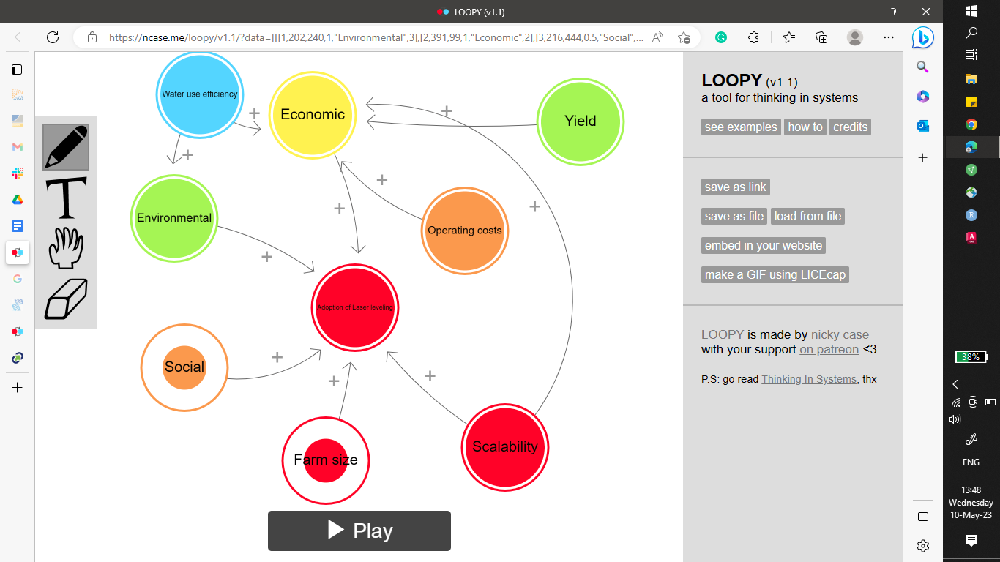

Tasks:

Read more into the aspects

Choose where to focus-> which approach would make sense?

Ask Frederrick for the old project-> what are the things we should look at? Targeting

**What do farmers value the most?**

Profit- logistics, inputs, capital cost, operating cost, ROI

Distance (location of rental company)